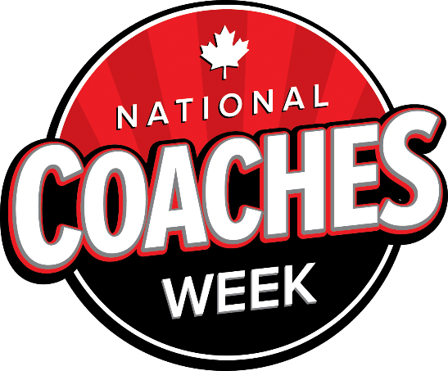
September 19-27, 2020
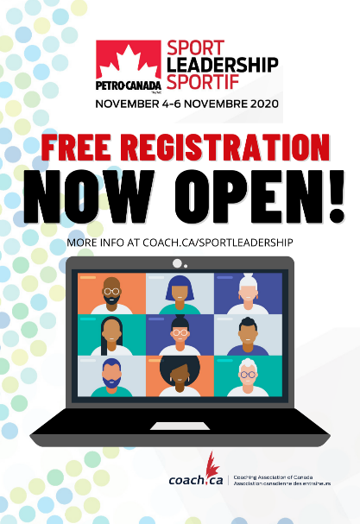
Join us at #SLS20 for a FREE virtual learning opportunity!
Catch Dr. Hadiya Roderique and Dr. Shimi Kang as part of a great lineup of speakers who will be motivating delegates to consider how intentional acts of courage, inclusivity, and resilience can shape positive change in Canada’s sport community.
Registration for the 2020 Petro-Canada Sport Leadership sportif conference is now open. The event will take place from November 4-6, 2020.
Explore our virtual event space for the latest updates and a full event schedule!
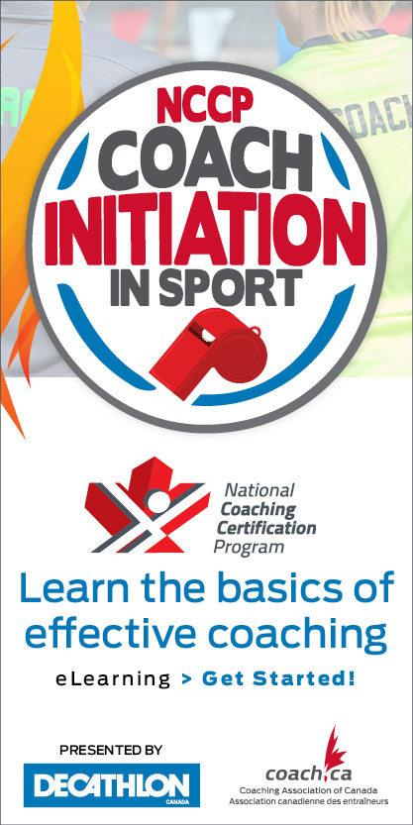
NCCP Coach Initiation in Sport
eLearning Relaunch
The CAC is excited to present an updated version of the NCCP
Coach Initiation in Sport eLearning module! This eLearning introduces
new and experienced coaches to the foundational skills of coaching,
such as long-term athlete development, ethics, coaching motivation,
and athlete safety and wellness.
The new version features updated content, a fresh look,
and is accessible across all technology devices. Coaches who have
already completed NCCP Coach Initiation in Sport are not
required to complete the new version.
Thanks to Decathlon Canada, the NCCP Coach Initiation in S
port eLearning will be offered for free during National Coaches Week
from September 19-27, 2020.
Visit coach.ca to learn more.
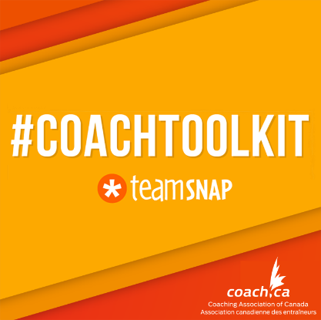
#CoachToolKit Infographic
Parents in sport: Tips for Coaches
Parents play an essential role in supporting their children in sport and activity.
In the latest #CoachToolKit infographic presented by TeamSnap, we take a look at five important tips for coaches and organizations who are ready to engage in proactive communication with parents.

Get concussion smart today
Coaches have an important role to help keep participants safe. Concussions can happen to anyone taking part in sport and recreation, and can sometimes have serious consequences.
The NCCP Making Head Way in Sport is a free eLearning module that will help coaches gain the knowledge and skills required to ensure the safety of their athletes. Start learning today!

Wildfire smoke, air quality and horses

https://www.facebook.com/171988471324/posts/10157724313826325/?vh=e&d=n
Northwest Equine Performance is with Riviera Equine Internal Medicine & Consulting.
Dr. Mark Revenaugh, Dr. Phoebe Smith and Dr. Austin Rowland discuss the Wildfire Smoke/Air Quality situation in the Pacific Northwest and implications for horses.

SafeSport Training from coach.ca https://thelocker.coach.ca/onlinelearning#SS

Safe, inclusive sport environments help make sport rewarding and enriching for all. By completing Safe Sport Training you will gain the knowledge and skills to create healthy and safe environments by recognizing, addressing and preventing maltreatment in sport.
After completing Safe Sport Training you will be able to:
- Understand that everyone has a role to play in keeping sport safe, how the misuse of power leads to maltreatment, and the principles of the Universal Code of Conduct.
- Understand the various types of maltreatment, the conditions that enable them, and how to recognize signs that they may be happening.
- Know what to do if you suspect maltreatment, and how you can create a culture that protects all participants. As of April 1, 2020, all Sport Canada - funded organizations are required to have training in abuse and harassment available to everyone under their immediate authority. Please identify the role for which you’ve been requested to completed this training. Your selection will trigger the appropriate version of the training.

The course is free and coaches will receive 2 PD points upon completion.

