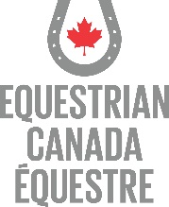
Equestrian Canada Registered Coach Requirements – April 2021
A Registered Coach must meet the following requirements:
Must be minimum 16 years of age.
Must hold a valid EC Sport License.
Must hold a valid PTSO Membership (if a Canadian resident).
Must complete the following mandatory Safe Sport training:
- EC’s Fostering Healthy Equestrian Environments e-learning module in the ECampus*;
- EC’s Concussion Awareness e-learning module in the ECampus*; and,
- Valid First Aid Certificate at the emergency or higher level of certification.
Provide a valid Certificate of Insurance confirming minimum coverage of $2,000,000 Commercial General Liability and $100,000 Professional Liability.
Screened by EC, meeting Level 2 screening requirements as outlined in EC’s Screening Policy, which includes the following:
- Application Form;
- Screening Disclosure Form;
- Participation in training, orientation and monitoring;
- ePIC criminal record check;
- One (1) letter of reference; and,
- Driver’s abstract (if requested).
Must provide declaration of good character as outlined in EC’s Screening Policy.
Formal acknowledgement of EC Code of Conduct and Ethics through completing EC Fostering Healthy Equestrian Environments.
For more information contact coaching@equestrian.ca

