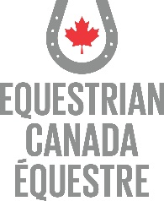
Registered Coach Status for Instructor and Coach candidates – Valid as of July 28, 2021
Requires at least 1 of the following courses Completed:
  - Equestrian Canada: Concussion Awareness
OR
  - Making Headway in Sport (Multisport)
Requires at least 1 of the following Completed
  - Enhanced Police Information Check (E-PIC)
OR
  - Criminal Record Check (Level 2)
Requires at least 1 of the following courses Completed
  - Standard First Aid
OR
  - Standard First Aid Blended
OR
  - Standard First Aid (Recert)
OR
  - Emergency First Aid
OR
  - Other recognized First Aid Certificate
Requires proof of Completed
- Certificate of Insurance – includes Professional Liability Insurance
Requires all 3 Completed
- Screening Disclosure Form
- 1 Coach Status Reference Letter
Requires at least 1 of the following courses Completed
  - Fostering Healthy Equestrian Environments
OR
  - Coaching Association of Canada Safe Sport Training
OR
  - Respect in Sport for Activity Leader

For a complete list of requirements go to www.equestrian.ca

