Region 1 Cohort Program

What is a Cohort
For the purposes of EC Certification, a cohort is a group of Instructor and Coach candidates who work together with a Learning Facilitator and a Coach developer. Within the cohort training the candidates will receive support, mentoring, and collaboration/discussion with other candidates. The cohort is run remotely using Zoom, Google Classroom and other online applications. The cohort is accessible to any member with access to High Speed Internet.

What is a Cohort?
The Region 1 Cohort is a joint venture between BC, Alberta, Saskatchewan and Manitoba, pooling resources and expertise to create a Program that is financially stable, accessible to any member and will help Instructor and Competition Coach candidates achieve success and certification.
Why a Cohort?
The cohort will address issues that candidates commonly face.
Evaluation Prep- Without a mentor, access to training and clear instructions of what is expected, evaluations can be very stressful to candidates.
Cost- EC certification can be very expensive for candidates. With mentoring, training, registering for in person evaluations, travel and potentially lost wages, a better solution was needed. Cost for candidates and includes training and mentoring.
Inefficient Process- So may steps from the application to completed evaluation, that candidates can feel overwhelmed if they don’t have a mentor to guide them. The cohorts are using Google Classroom and HCBC’s Coaching Handbook and Resources platform. Clear resources and a step-by-step approach to working through the evaluation made available to candidates.
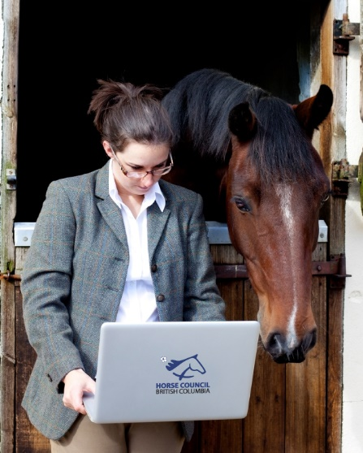
Location: It’s hard to find facilities willing to host evaluations in all areas of the Province. Evaluations were not accessible to candidates in remote area’s forcing extra time and travel for those candidates. Process will be completed through a digital platform and video evaluation. This makes it accessible to everyone!
Lack of understanding the context- Candidates are not always clear on the requirements and what they need to demonstrate. What does a successful lesson look like? Am I teaching a lesson too advanced or not advanced enough? Am I using the right terminology for the context I am seeking certification for?
Understanding the learning process- Without a mentor, NCCP training and a lot of practice, the candidate may not be aware of teaching technique, body language and voice projection.
Access to Information: EC NCCP Theory modules are built into the cohort schedule. Proper pre-brief & debrief for each evaluation outcome by a Coach Evaluator.
How to participate in a Cohort:
Intake of applications will take place approximately 1 month prior to the start date of the training. Interested candidates will submit proof of the requirements, the applications are checked for completeness and then the successful candidates are notified. At this time the candidate will pay for the cohort access and they are then given all of the links and information for the start of the training.
What is required in order to participate in the Cohort?
- Current Equestrian Canada Registered or Licensed Coach status
- Completed the appropriate Learn to Ride level
  - English 6 for Instructor
  - English 8 for Competition Coach
  - Western 4 for Instructor
  - Western Intermediate Rider Basic Training and Western Rider 4 for Competition Coach
- Completed the Make Ethical Decisions online assessment (www.coach.ca)
- Completed the Understanding the Rule of Two training
- Registered for the CHAR platform (optional, free for HCBC members)
- Have access or own the EC Stable Management and Learn to Ride manuals
- Access to high-speed internet, video camera, microphone, MS Word or another document editor
- Gmail account
- Access to a facility for recording video
  - Riders and school horses at Rider 3 or 4 level or Western Level 3 or 4
  - Riders and school horses the English Rider 7 or 8 level or Western Rider 4
- Dedicated time for zoom sessions, homework and filming lessons

Candidates involved in an Instructor or Competition Coach training and certification cohort will be expected to:
Take the Training: Attend the cohort meeting, complete “homework” between meetings including building portfolio pieces and filming lessons for evaluations

Collaborate with Peers: Share ideas, input, feedback and learning with your colleagues in the cohort. Engage in discussions during the meetings to prepare for the evaluation.

Embrace the Opportunity: Work with a mentor through training and evaluation to improve your coaching skills. Complete your certification by video at your own facility, with horses and riders and the environment you are familiar with.

Expectations of the Candidate

Timeline for the cohort
English or Western Instructor
- 15 meetings to be delivered online weekly
  - 5 with a duration of 2:30 hours
  - 10 with a duration of 1:30 hours
The cohort will provide the candidate with the tools, training and mentoring required to be evaluated as well as carry those skills on to their coaching business. Candidates are not guaranteed successful evaluations. It is up to the candidate to take the training seriously, practice, participate and take advantage of the mentoring available. Missing class and not submitting homework will jeopardize the candidates place in the cohort and ability to be evaluated.
Participation in an online cohort is one way to pursue certification. Candidates can still work and prepare with a mentor, or prepare on their own. Evaluations are offered by video, or in person through HCBC.

For more information about Cohort training or the Equestrian Canada Coach and Instructor certification programs contact:
coaching@hcbc.ca
or visit
www.hcbc.ca

V1 November 2023

You are responsible for your own success
English or Western Competition Coach
- 13 meetings to be delivered online weekly
  - 5 meetings with a duration of 2:30 hours
  - 8 meetings with a duration of 1:30 hours

The Coach develops and Learning Facilitators will use a variety of training resources during each weekly session.

- Coach Handbook and Resource Guide
- NCCP Theory Classes
- Video reviews
- Group discussion
- One on one mentoring and feedback
- Access to rubrics and evaluation tools.

Cohort participants will be given the schedule, and all other information for the training when they have been assigned a spot in the cohort.

How do I apply to apply to join a cohort?

- Contact coaching@hcbc.ca to be put on the wait list
- When the intake begins you will be contacted with the link to send your applications
- Provide proof of the requirements to your PSO which they will enter into the Smartsheet portal
- Successful applications will be notified. Space is limited.
- Provide payment (Alberta Equestrian is currently handling the payments)
- You will be provided with instructions and information via email
- Mark the start date and zoom dates on your calendar and get ready to participate.

